Content

Midterm 期中考範圍 |  | Final 期末考範圍
My Next Reading 3 |  | My Next Reading 3
U1 I’m Not Sick!................ | 1 |  | U9 A Special Camping Dinner.. | 9
U2 Let’s Reduce Garbage… | 1 |  | U10 Colorful Food.................... | 9
U3 Hi, Robots!................... | 3 |  | U11 Jim’s Very Long Day ….... | 11
U4 Smartphones................. | 3 |  | U12 Thank You, Friends! …... | 11
U5 The Rules of Sharon’s House…. | 5 |  | U13 The Scary Haunted House...... | 13
U6 Amazing Magnets........ | 5 |  | U14 National Flags................ | 13
U7 At the Airport............... | 7 |  | U15 A New Calendar............... | 15
U8 From Babies to Adults... | 7 |  | U16 The Boy Who Cried Wolf...... | 15
Brown Bear Phonics 4 |  | Brown Bear Phonics 4
U1 Vowels : oo, ou/ow....... | 2 |  | U5 Blends with l and r............. | 1 10
U2 Vowels : aw/au/al, oi/oy... | 4 |  | U6 Blends with s.................... | 12
U3 Vowels : ar/or, er/ir/ur.... | 6 |  | U7 Soft c and soft g sounds...... | 14
U4 Vowels + Consonants..... | 8 |  | U8 nk/ng and silent consonants.. | 16
Stories課文翻譯 |  | Stories課文翻譯
U1 I’m Not Sick!................ | 17 |  | U9 A Special Camping Dinner.. | 25
U2 Let’s Reduce Garbage… | 18 |  | U10 Colorful Food.................... | 26
U3 Hi, Robots!................... | 19 |  | U11 Jim’s Very Long Day….... | 27
U4 Smartphones................. | 20 |  | U12 Thank You, Friends! …... | 28
U5 The Rules of Sharon’s House…. | 21 |  | U13 The Scary Haunted House...... | 29
U6 Amazing Magnets........ | 22 |  | U14 National Flags................ | 30
U7 At the Airport............... | 23 |  | U15 A New Calendar............... | 31
U8 From Babies to Adults... | 24 |  | U16 The Boy Who Cried Wolf...... | 32
 |  |  |  | 33
  My Next Reading 3習作解答........................................... | 33
單字表原則上按照週次安排進行背誦，畫斜線為認讀字。
v.= verb動詞 a.= adjective形容詞 adv.= adverb副詞
n.=noun名詞 pron.=pronoun代名詞 prep.=preposition介系詞
ph.=phrase片語 conj.= conjunction連接詞 aux.= auxiliary verb助動詞

My Next Reading 3 U1 I’m Not Sick!
 |  | English | 詞性/中文 |  | Week/Date | 家長簽名
1 |  | headache | n. | 頭痛 | W3/
2 |  | runny nose | n. | 流鼻水 | W3/
3 |  | cough | n. | 咳嗽 | W3/
4 |  | sore throat | n. | 喉嚨痛 | W3/
5 |  | medicine | n. | 藥 | W3/
6 |  | shot | n. | 注射 | W3/

My Next Reading 3 U2 Let’s Reduce Garbage
 |  | English | 詞性/中文 |  | Week/Date | 家長簽名
7 |  | garbage | n. | 垃圾 | W4/
8 |  | reduce | v. | 減少 | W4/
9 |  | recycle | v. | 回收；再利用 | W4/
10 |  | carton | n. | 紙盒 | W4/
11 |  | toilet paper | n. | 衛生紙 | W4/
12 |  | earth | n. | 地球 | W4/
BB4 U1 Vowels: oo, ou/ow
 |  | English | 詞性/中文 | Week/Date | 家長簽名
13 |  | spoon | n. 湯匙 | W3/
14 |  | boots | n. 靴子(複數) | W3/
15 |  | room | n. 房間 | W3/
16 |  | roof | n. 屋頂 | W3/
17 |  | noon | n. 中午 | W3/
18 |  | mouse | n. 老鼠 | W3/
19 |  | trousers | n. 長褲 | W3/
20 |  | ground | n. 地面 | W3/
21 |  | brown | - 棕色的 | W4/
22 |  | shower | v. 淋浴 | W4/
23 |  | down | adv.向下 | W4/
24 |  | flower | n. 花 | W4/

My Next Reading 3 U3 Hi, Robots!
 |  | English | 詞性/中文 |  | Week/Date | 家長簽名
25 |  | cook | n. | 廚師 | W5/
26 |  | apron | n. | 圍裙 | W5/
27 |  | musician | n. | 音樂家 | W5/
28 |  | tailcoat | n. | 燕尾服 | W5/
29 |  | wag | v. | 搖擺 | W5/
30 |  | lick | v. | 舔 | W5/

My Next Reading 3 U4 Smartphones
 |  | English | 詞性/中文 |  | Week/Date | 家長簽名
31 |  | record | v. | 記錄；錄影 | W6/
32 |  | chat | v. | 聊天 | W6/
33 |  | map | n. | 地圖 | W6/
34 |  | download | v. | 下載 | W6/
35 |  | harmful | a. | 有害的 | W6/
36 |  | neck | n. | 脖子 | W6/
BB4 U2 Vowels: aw/au/al, oi/oy
 |  | English | 詞性/中文 | Week/Date | 家長簽名
37 |  | draw | v. 畫畫 | W4/
38 |  | straw | n. 吸管 | W4/
39 |  | law | n. 法律 | W4/
40 |  | sauce | n. 醬汁 | W4/
41 |  | August | n. 八月 | W4/
42 |  | daughter | n. 女兒 | W4/
43 |  | wall | n. 牆壁 | W4/
44 |  | oil | n. 油 | W4/
45 |  | point | v. 指著 | W5/
46 |  | toilet | n. 廁所；馬桶 | W5/
47 |  | soy | n. 大豆 | W5/
48 |  | joy | n. 歡樂 | W5/

My Next Reading 3 U5 The Rules of Sharon’s House
 |  | English | 詞性/中文 |  | Week/Date | 家長簽名
49 |  | visit | v. | 拜訪 | W7/
50 |  | dinner | n. | 晚餐 | W7/
51 |  | dish | n. | 碗盤 | W7/
52 |  | sink | n. | 水槽 | W7/
53 |  | share | v. | 分享；分攤 | W7/
54 |  | chore | n. | 家庭雜務 | W7/

My Next Reading 3 U6 Amazing Magnets
 |  | English | 詞性/中文 |  | Week/Date | 家長簽名
55 |  | magnet | n. | 磁鐵 | W8/
56 |  | north | a. | 北方的 | W8/
57 |  | south | a. | 南方的 | W8/
58 |  | push | v. | 推 | W8/
59 |  | paper clip | n. | 迴紋針 | W8/
60 |  | steel | n. | 鋼鐵 | W8/
BB4 U3 Vowels: ar/or, er/ir/ur
 |  | English | 詞性/中文 | Week/Date | 家長簽名
61 |  | farm | n. 農場 | W6/
62 |  | jar | n. (寬口的)罐子 | W6/
63 |  | yard | n. 庭院 | W6/
64 |  | sport | n. 運動 | W6/
65 |  | torch | n. 手電筒 | W6/
66 |  | storm | n. 暴風雨 | W6/
67 |  | short | - 短的；矮的 | W6/
68 |  | mother | n. 母親 | W7/
69 |  | shirt | n. 襯衫 | W7/
70 |  | surf | v. 衝浪 | W7/
71 |  | curly | - 捲曲的 | W7/

My Next Reading 3 U7 At the Airport
 |  | English | 詞性/中文 |  | Week/Date | 家長簽名
72 |  | airport | n. | 機場 | W9/
73 |  | hurry | v. | 急忙 | W9/
74 |  | ticket | n. | 票 | W9/
75 |  | baggage | n. | 行李 | W9/
76 |  | passport | n. | 護照 | W9/
77 |  | tired | a. | 疲倦的 | W9/

My Next Reading 3 U8 From Babies to Adults
 |  | English | 詞性/中文 |  | Week/Date | 家長簽名
78 |  | cub | n. | 幼獸 | W9/
79 |  | adult | n. | 成年人；已長大的動物與植物 | W9/
80 |  | lay | v. | 下蛋 | W9/
81 |  | chick | n. | 小雞 | W9/
82 |  | wet | a. | 濕的 | W9/
83 |  | feather | n. | 羽毛 | W9/
BB4 U4 Vowels + Consonants
 |  | English | 詞性/中文 | Week/Date | 家長簽名
84 |  | sock | n. 襪子 | W8/
85 |  | train | n. 火車 | W8/
86 |  | fries | n. 薯條 | W8/
87 |  | kite | n. 風箏 | W8/
88 |  | child | n. 小孩 | W8/
89 |  | news | n. 新聞 | W8/
90 |  | game | n. 遊戲 | W8/
91 |  | feet | n. 腳(foot的複數) | W8/
92 |  | day | n. 白天 | W9/
93 |  | fly | n. 蒼蠅 | W9/
94 |  | throw | v. 丟；擲 | W9/
95 |  | music | n. 音樂 | W9/
Midterm

My Next Reading 3 U9 A Special Camping Dinner
 |  | English | 詞性/中文 |  | Week/Date | 家長簽名
96 |  | tent | n. | 帳篷 | W11/
97 |  | pail | n. | 提桶 | W11/
98 |  | campfire | n. | 營火 | W11/
99 |  | barbecue | n. | 烤肉 | W11/
100 |  | candy | n. | 糖果 | W11/
101 |  | hungry | a. | 餓的 | W11/

My Next Reading 3 U10 Colorful Food
 |  | English | 詞性/中文 |  | Week/Date | 家長簽名
102 |  | heart | n. | 心臟 | W12/
103 |  | protect | v. | 保護 | W12/
104 |  | spinach | n. | 波菜 | W12/
105 |  | bone | n. | 骨頭 | W12/
106 |  | onion | n. | 洋蔥 | W12/
107 |  | stomach | n. | 胃 | W12/
BB4 U5 Blends with l and r
 |  | English | 詞性/中文 | Week/Date | 家長簽名
108 |  | blanket | n. 毛毯 | W11/
109 |  | clean | - 清潔的；  洗過的 | W11/
110 |  | floor | n. 地板 | W11/
111 |  | glasses | n. 眼鏡 | W11/
112 |  | sleep | v. 睡覺 | W11/
113 |  | slam | v. 猛地關上 | W11/
114 |  | brother | n. 兄弟 | W11/
115 |  | crocodile | n. 鱷魚 | W11/
116 |  | drink | n. 飲；喝 | W12/
117 |  | grass | n. 青草；草地 | W12/
118 |  | present | n. 禮物；贈品 | W12/
119 |  | treasure | n. 寶藏 | W12/

My Next Reading 3 U11 Jim’s Very Long Day
 |  | English | 詞性/中文 |  | Week/Date | 家長簽名
120 |  | magician | n. | 魔術師 | W13/
121 |  | vet | n. | 獸醫 | W13/
122 |  | sick | a. | 生病的 | W13/
123 |  | pilot | n. | 飛行員 | W13/
124 |  | firefighter | n. | 消防員 | W13/
125 |  | save | v. | 救 | W13/

My Next Reading 3 U12 Thank You, Friends!
 |  | English | 詞性/中文 |  | Week/Date | 家長簽名
126 |  | right | a. | 右邊的 | W14/
127 |  | hurt | v. | 疼痛 | W14/
128 |  | carry | v. | 拿；提；背 | W14/
129 |  | notebook | n. | 筆記本 | W14/
130 |  | juice | n. | 果汁 | W14/
131 |  | spill | v. | 溢出；潑灑 | W14/
BB4 U6 Blends with s
 |  | English | 詞性/中文 | Week/Date | 家長簽名
132 |  | skip | v. 跳過 | W13/
133 |  | skate | v. 溜冰 | W13/
134 |  | smell | v. 聞 | W13/
135 |  | smile | v. 微笑 | W13/
136 |  | smoke | n. 煙 | W13/
137 |  | snack | n. 點心 | W13/
138 |  | spider | n. 蜘蛛 | W13/
139 |  | spot | n. 汙漬 | W13/
140 |  | spring | n. 春天 | W13/
141 |  | stand | v. 站立 | W14/
142 |  | street | n. 街道 | W14/
143 |  | sweater | n. 毛衣 | W14/
144 |  | swing | n. 鞦韆 | W14/

My Next Reading 3 U13 The Scary Haunted House
 |  | English | 詞性/中文 |  | Week/Date | 家長簽名
145 |  | amusement park | n. | 遊樂園 | W15/
146 |  | bored | a. | 無聊的 | W15/
147 |  | roller coaster | n. | 雲霄飛車 | W15/
148 |  | haunted house | n. | 鬼屋 | W15/
149 |  | worry | v. | 擔心 | W15/
150 |  | ghost | n. | 鬼 | W15/

My Next Reading 3 U14 National Flags
 |  | English | 詞性/中文 |  | Week/Date | 家長簽名
151 |  | flag | n. | 旗 | W16/
152 |  | large | a. | 大的 | W16/
153 |  | small | a. | 小的 | W16/
154 |  | gold | a. | 金色的 | W16/
155 |  | harmony | n. | 和諧 | W16/
156 |  | stripe | n. | 條紋 | W16/
BB4 U7 Soft c and soft g sounds
 |  | English | 詞性/中文 | Week/Date | 家長簽名
157 |  | celery | n. 芹菜 | W15/
158 |  | ceiling | n. 天花板 | W15/
159 |  | mice | n. 老鼠  (mouse的複數) | W15/
160 |  | cinema | n. 電影院 | W15/
161 |  | circus | n. 馬戲團 | W15/
162 |  | bicycle | n. 腳踏車 | W15/
163 |  | cymbals | n. 鈸(複數) | W15/
164 |  | cycle | n. 循環 | W15/
165 |  | gem | n. 寶石 | W16/
166 |  | giraffe | n. 長頸鹿 | W16/
167 |  | giant | a. 巨大的 | W16/
168 |  | gym | - 健身房 | W16/

My Next Reading 3 U15 A New Calendar
 |  | English | 詞性/中文 |  | Week/Date | 家長簽名
169 |  | December | n. | 十二月 | W17/
170 |  | calendar | n. | 日曆 | W17/
171 |  | sketchbook | n. | 素描本 | W17/
172 |  | star | n. | 星星 | W17/
173 |  | page | n. | 頁 | W17/
174 |  | line | n. | 線 | W17/

My Next Reading 3 U16 The Boy Who Cried Wolf
 |  | English | 詞性/中文 |  | Week/Date | 家長簽名
175 |  | sheep | n. | 綿羊 | W18/
176 |  | hill | n. | 丘陵；小山 | W18/
177 |  | idea | n. | 主意；想法 | W18/
178 |  | wolf | n. | 狼 | W18/
179 |  | neighbor | n. | 鄰居 | W18/
180 |  | lie | n. | 謊言 | W18/
BB4 U8 nk/ng and silent consonants
 |  | English | 詞性/中文 | Week/Date | 家長簽名
181 |  | think | v. 思考 | W17/
182 |  | wings | n. 翅膀(複數) | W17/
183 |  | knife | n. 刀子 | W17/
184 |  | knee | n. 膝蓋 | W17/
185 |  | knock | v. 敲 | W17/
186 |  | knot | n. 蝴蝶結 | W17/
187 |  | write | v. 寫 | W17/
188 |  | wrong | - 錯誤的 | W17/
189 |  | wrist | n. 手腕 | W17/
190 |  | wrap | v. 包裝 | W17/
191 |  | climb | v. 攀爬 | W18/
192 |  | comb | n. 梳子 | W18/
193 |  | lamb | n. 小羊 | W18/
194 |  | thumb | n. 大拇指 | W18/

Unit 1 I’m Not Sick!

CD 03-04
A: Mom, I can’t go to school today.  I have a headache.  I have a fever.  I have a runny nose and a cough.  I have a sore throat.  B: Oh, you should see a doctor.  Ryan goes to see a doctor with Mom.  C: You have a bad cold.  You should drink warm water.  You should take some medicine.  And you should get a shot.  A: Oh no! I want to go to school.  I'm not sick! | A: 媽媽，我今天不能上學。  我頭痛。  我發燒。  我流鼻水和咳嗽。  我喉嚨痛。  B: 喔，你應該看醫生。  Ryan和媽媽去看醫生。  C: 你有很嚴重的感冒。  你應該要喝溫開水。  你應該要吃藥。  然後你應該要打針。  A: 喔不！我想要去上學。  我沒有生病！

Unit 2 Let’s Reduce Garbage
CD 06-07
There is too much garbage around us.  How can we reduce the garbage?  What about recycling?  Look at your garbage can.  Take out milk cartons and plastic bottles.  Take out cans and glass bottles too.  We can recycle all of them.  We make new things by recycling.  Old paper turns into new toilet paper.  Old plastic bottles change into new phone cases.  Old cans change into new bikes.  Recycling can make our earth cleaner. | 我們身邊有太多垃圾。  我們可以怎麼減少垃圾呢？  回收再利用如何？  看看你的垃圾桶。  拿出牛奶盒和塑膠瓶。  也拿出金屬罐和玻璃瓶。  我們可以把它們全部回收再利用。  我們利用回收再製造新的物品。  舊的紙變成新的衛生紙。  舊的塑膠瓶變成新的手機殼。  舊的金屬罐變成新的腳踏車。  回收再利用可以讓地球更乾淨。

Unit 3 Hi, Robots!
CD 09-10
Our class goes on a field trip.  We are at a robot museum.  This robot looks like a cook.  It is wearing a white apron and a hat.  It is making different foods at the same time.  That robot looks like a musician.  It is wearing a black tailcoat.  It is playing many musical instruments at the same time.  “Woof! Woof!”  A robot dog barks and wags its tail.  It licks our hands like a real dog.  What wonderful robots! | 我們班參加校外教學。  我們在一間機器人博物館。  這個機器人看起來像一位廚師。  它穿著一件白色圍裙和一頂帽子。  它可以同時做著不同的食物。  那個機器人看起來像一位音樂家。  它穿著一件黑色燕尾服。  它可以同時演奏著不同的樂器。  「汪！汪！」  一隻機器狗一邊叫一邊搖它的尾巴。  它像一隻真的狗舔我們的手。  多麼棒的機器人啊！

Unit 4 Smartphones
CD 12-13
Smartphones are very useful.  They are also easy to use.  What can we do with smartphones?  We can record videos and share them.  We can chat online with anyone.  We can surf the internet.  We can use maps and find the way.  We can download e-books and read them.  Are you always with your smartphone?  Smartphones can be harmful to you.  They can be bad for your eyes and neck.  Don’t spend too much time on your smartphone. | 智慧型手機很實用。  它們也很容易使用。  我們可以用智慧型手機做什麼呢？  我們可以錄影然後分享。  我們可以在線上跟任何人聊天。  我們可以上網。  我們可以用地圖找到路。  我們可以下載電子書然後閱讀。  你總是拿著你的智慧型手機嗎？  智慧型手機會對你有害。  它們對你的眼睛和脖子是有害的。  不要花太多時間在智慧型手機上。

Unit 5 The Rules of Sharon’s House
CD 15-16
Nadia visits Sharon’s house.  They watch TV in the living room.  After two hours, Sharon turns it off.  A: We should watch only two hours of TV a  day.  It’s time for dinner.  A: We should not use cellphones at dinner time.  We can have more time to talk together.  After the meal, Sharon puts her dishes in the sink.  A: We should share house chores.  B: Oh, there are too many rules.  I can’t live in your house. | Nadia拜訪Sharon的家。  她們在客廳看電視。  兩個小時後，Sharon把電視關掉。  A: 我們一天應該只看兩個小時的電  視。  晚餐時間到了。  A: 我們不應該在晚餐時間使用手機。  我們可以有更多時間一起聊天。  用餐後，Sharon把她的碗盤放到水槽裡。  A: 我們應該分擔家事。  B: 喔，有太多規定了。  我沒有辦法住在你家。

Unit 6 Amazing Magnets
CD 18-19
Look at these magnets.  Magnets have two ends.  One is a north pole.  The other is a south pole.  Put the same poles together.  They push away from each other.  Put the different poles together.  They pull toward each other.  Do magnets pull other things?  Put some nails, paper clips, erasers, and pencils near a magnet.  The nails and the paper clips move toward the magnet.  The erasers and the pencils don’t move.  Magnets only pull steel. | 看看這些磁鐵。  磁鐵有兩端。  一端是北極。  另一端是南極。  把相同的磁極放一起。  它們會互相推開。  把不同的磁極放一起。  它們會互相吸引。  磁鐵會吸引其他東西嗎？  放一些釘子、迴紋針、橡皮擦和鉛筆在一塊磁鐵附近。  釘子和迴紋針會向磁鐵靠近。  橡皮擦和鉛筆不會移動。  磁鐵只會吸引鋼鐵。

Unit 7 At the Airport
CD 21-22
Today my family travels to Canada.  We are at the airport now.  What time is it? It’s nine o’clock.  Hurry up. We should get the tickets.  Then we should check in our baggage.  What time is it? It’s ten o’clock.  Hurry up. We should show our passports.  Then we should pass the security check.  What time is it? It’s eleven o’clock.  Hurry up. We should get on the airplane.  Phew.... I’m so tired, but it’s fun. | 今天我們全家去加拿大旅行。  我們此時在機場。  現在幾點鐘了？九點鐘了。  快點。我們應該要拿機票。  接著我們應該要托運我們的行李。  現在幾點鐘了？十點鐘了。  快點。我們應該要出示我們的護照。  接著我們應該要通過安全檢查。  現在幾點鐘了？十一點鐘了。  快點。我們應該要上飛機。  呼……我好累，但是玩得很開心。

Unit 8 From Babies to Adults
CD 24-25
Pandas give birth to tiny and pink cubs.  The cubs don’t open their eyes at first.  After one month, they have black and  white hair.  After four months, they can walk and run.  After five years, they become adults.  Hens lay their eggs.  They keep the eggs warm.  After twenty-one days, chicks come out of the eggs.  They are wet at first, but soon become dry.  After thirty days, they have feathers.  After six months, they become adults. | 熊貓生出又小又粉嫩的幼獸。  幼獸一開始不會睜開牠們的眼睛。  一個月之後，牠們長出黑色和白色的毛。  四個月之後，牠們會走路和跑步。  五年之後，牠們變為成年動物。  母雞下蛋。  牠們讓雞蛋保持溫暖。  二十一天之後，小雞從雞蛋裡面孵化出來。  牠們一開始很濕，但很快變乾。  三十天之後，牠們長出羽毛。  六個月之後，牠們成為成年動物。

Unit 9 A Special Camping Dinner
CD 27-28
My family goes camping near a river.  First, Dad puts up a tent.  Then we go fishing!  Sadly there are no fish in our pail.  The sun goes down.  We sit around the campfire.  Let’s have a barbecue.  Oh no! The food box is at home.  Just then, my little sister opens her backpack.  There are some candy and chocolate bars inside.  We eat them together.  We have fun at the camp.  However, we are still hungry. | 我們全家去小河附近露營。  首先，爸爸搭了一頂帳篷。  接著我們去釣魚！  很遺憾地我們的桶子裡沒有魚。  太陽下山。  我們圍著營火坐。  我們來烤肉吧。  喔不！食物盒在家。  就在那時候，我的妹妹打開她的後背包。  裡面有一些糖果和巧克力棒。  我們一起吃。  我們在營地玩得很開心。  然而，我們還是很餓。
Unit 10 Colorful Food
CD 30-31
Fruits and vegetables are colorful.  These colorful foods are good for your health.  Tomatoes and strawberries are red.  They are good for your heart.  Carrots and pumpkins are orange.  They are good for your eyes.  Grapes and blueberries are purple.  They protect your body from disease.  Spinach and broccoli are green.  They build healthy bones.  Onions and radishes are white.  They are good for your stomach.  Look at the food on your plate.  What colors do you see? | 水果和蔬菜是五顏六色的。  這些五顏六色的食物對你的健康有益。  番茄和草莓是紅色的。  它們對你的心臟有益。  胡蘿蔔跟南瓜是橘色的。  它們對你的眼睛有益。  葡萄和藍莓是紫色的。  它們會保護你的身體免受疾病的侵襲。  菠菜和青花椰菜是綠色的。  它們建造健康的骨骼。  洋蔥和小蘿蔔是白色的。  它們對你的胃有益。  看看你盤子裡的食物。  你看見什麼顏色？

Unit 11 Jim’s Very Long Day
CD 33-34
One day, Jim meets a man.  A: Who are you?  B: I’m a magician.  A: Magician, can you change me?  B: Sure! What do you want to be?  A: I want to be a vet.  B: Abracadabra!  Jim helps sick animals.  A: Now I want to be a pilot.  B: Abracadabra!  Jim flies an airplane.  A: How about a firefighter?  B: Abracadabra!  Jim puts out a fire and saves people.  B: And next, how about....  A: Wait! I'm tired. Please turn me back!  I like being a student. | 有一天，Jim遇見一位男士。  A: 你是誰？  B: 我是一位魔術師。  A: 魔術師，你可以改變我嗎？  B: 當然！你想要變成什麼？  A: 我想變成一位獸醫。  B: 阿布拉卡達布拉！  Jim幫助生病的動物。  A: 現在我想變成一位飛行員。  B: 阿布拉卡達布拉！  Jim開飛機。  A: 那麼消防員呢？  B: 阿布拉卡達布拉！  Jim滅火和救人。  B: 接著，要不要……  A: 等等！我累了。請把我變回來！  我喜歡當一位學生。

Unit 12 Thank You, Friends!
Fred’s right arm hurts.  He needs some help.  Fred can’t carry his bag.  Mason wants to help him.  Mason carries Fred’s bag to the school.  “Thank you,” Fred says.  Fred can’t write in his notebook.  Nancy wants to help him.  Nancy writes in Fred’s notebook.  “Thank you,” Fred says.  Adam brings some bread and juice to Fred.  But Adam spills the juice on Fred’s shirt.  “Sorry,” Adam says.  “That’s okay,” Fred says.  “My shirt looks cool with the orange dots.” | Fred的右邊手臂疼痛。  他需要一些幫助。  Fred沒辦法拿起他的包包。  Mason想要幫助他。  Mason拿著Fred的包包到學校。  「謝謝你。」Fred說。  Fred沒辦法在他的筆記本上寫字。  Nancy想要幫助他。  Nancy幫Fred記筆記。  「謝謝你。」Fred說。  Adam帶一些麵包和果汁給Fred。  但是Adam把果汁灑在Fred的襯衫上。  「對不起。」Adam說。  「沒關係。」Fred說。  「我的襯衫上有橘色的點點看起來很  酷。」
CD 36-37

Unit 13 The Scary Haunted House
CD 39-40
Emily and Noah are at the amusement park.  First, they go riding a merry-go-round.  It goes round and round.  A: Is it fun?  B: No, I’m bored.  Next, they go riding a roller coaster.  It goes very fast.  B: I’m still bored.  How about the haunted house?  A: No, I’m scared.  B: Don’t worry. I’m with you.  They get in the haunted house.  B: Aargh! I see the real ghosts.  Let’s get out!  A: Ha ha! Don’t be so scared.  I’m with you. | Emily和Noah在遊樂園。  首先，他們去坐旋轉木馬。  它轉呀轉。  A: 很好玩嗎？  B: 不，我很無聊。  接著，他們去坐雲霄飛車。  它行進得非常快。  B: 我還是很無聊。  那麼鬼屋呢？  A: 不，我很害怕。  B: 不要擔心。我會在你身邊。  他們進去鬼屋。  B: 啊！我看見真的鬼。  我們出去吧！  A: 哈哈！不要那麼害怕。  我會在你身邊。

Unit 14 National Flags
CD 42-43
This is the national flag of China.  It has one large star and four small stars.  The stars are gold.  And they are on a red rectangle.  The stars mean the harmony of the Chinese people.  This is the national flag of the US.  It has fifty stars and thirteen stripes.  The stars are white on a blue rectangle.  The stripes are red and white.  The stars mean the number of the states. | 這是中國的國旗。  它有一顆大星星和四顆小星星。  星星是金色的。  它們在一個紅色長方形上。  星星意味著中國人民的和諧。  這是美國的國旗。  它有五十顆星星和十三條條紋。  藍色長方形上的星星是白色的。  條紋是紅色和白色的。  星星代表著州的數量。

Unit 15 A New Calendar
CD 45-46
It’s already December.  Julia and Harry make a calendar for next year.  Harry brings a sketchbook and crayons.  Julia brings some star stickers.  Harry writes the months on twelve pages.  And he draws lines on each page.  Julia writes the days and the dates.  And she draws some pictures on each month.  Lastly, Harry puts the star stickers on the holidays.  “Wow! We have many holidays next year!”  “Hooray!” they shout with joy. | 已經十二月了。  Julia和Harry做了明年的月曆。  Harry帶了一本素描本和蠟筆。  Julia帶了一些星星貼紙。  Harry寫月份在十二頁月曆紙上。  接著他在每一頁上畫線。  Julia寫上星期和日期。  接著她在每一個月上畫一些圖片。  最後，Harry把假日貼上星星貼紙。  「哇！明年我們有很多假日！」  「好棒！」他們歡呼著。

Unit 16 The Boy Who Cried Wolf
A boy watches sheep on the hill.  He is very bored.  He has a fun idea.  He shouts, “Help! Wolf!”  His neighbors run to help him.  However, there is no wolf.  They go back.  He is bored again.  He shouts, “Help! Wolf!”  His neighbors run to him again.  However, there is no wolf.  They are very angry at him.  They say, “Don't tell a lie!”  Later he sees a wolf.  He shouts, “Help! Wolf!”  However, nobody comes to help him. | 一位男孩在山坡上照顧羊。  他非常的無聊。  他有一個有趣的想法。  他大喊：「救命！有狼！」  他的鄰居跑來幫他。  然而，連一匹狼都沒有。  他們回去了。  他又無聊了。  他大喊：「救命啊！有狼！」  他的鄰居又跑來幫助他。  然而，連一匹狼都沒有。  他們對他非常的生氣。  他們說：「不要說謊！」  晚些時候他看見一匹狼。  他大喊：「救命！有狼！」  然而，沒有人來幫他。
CD 48-49
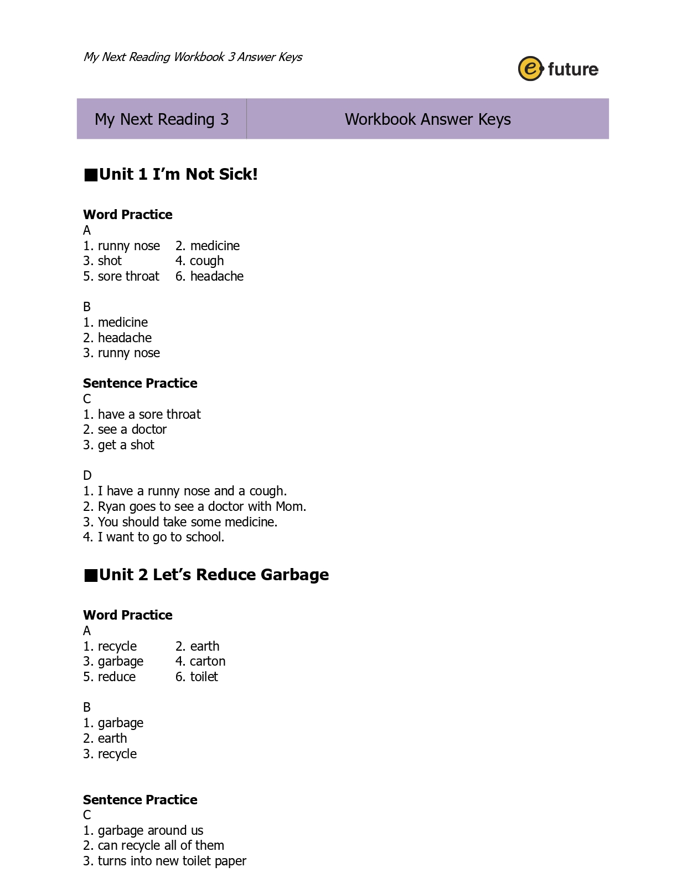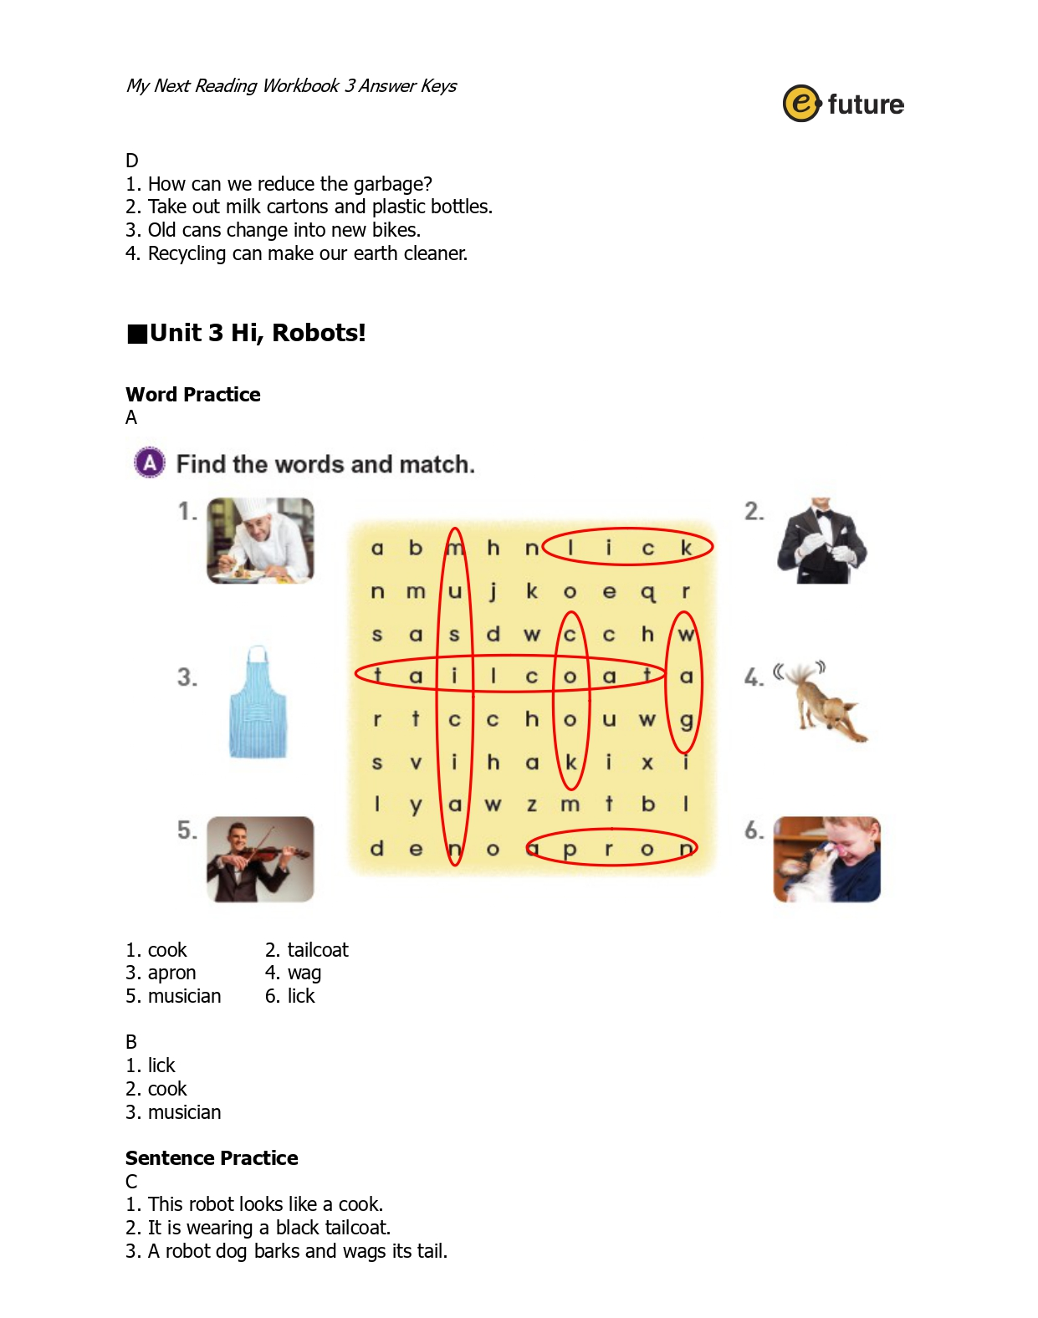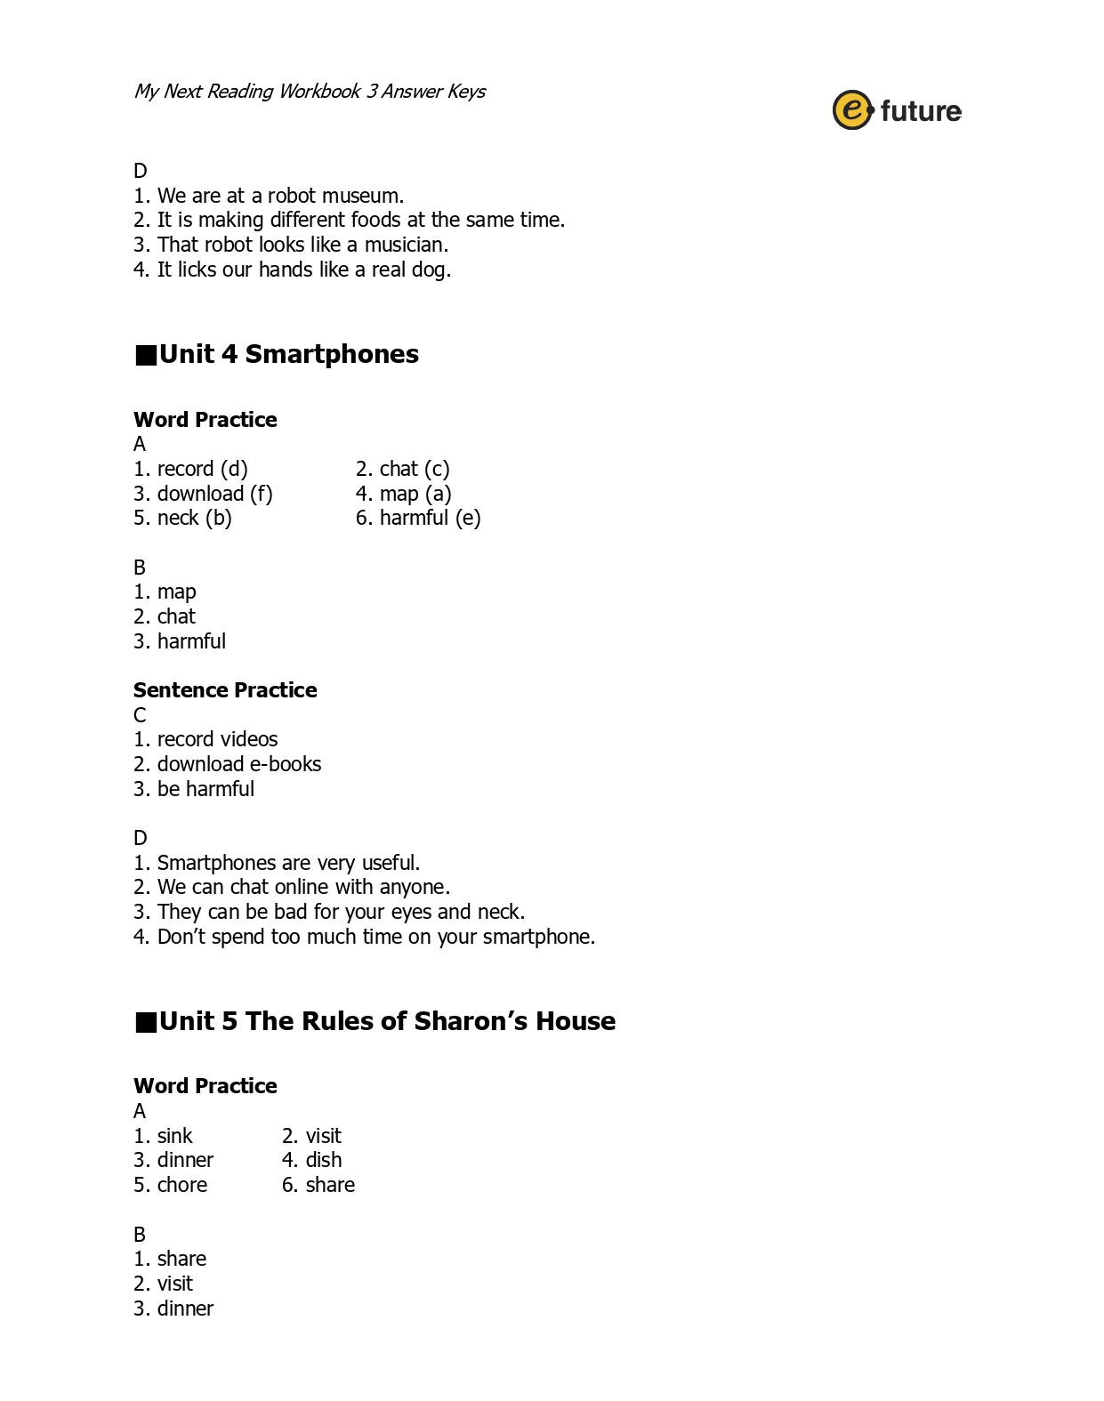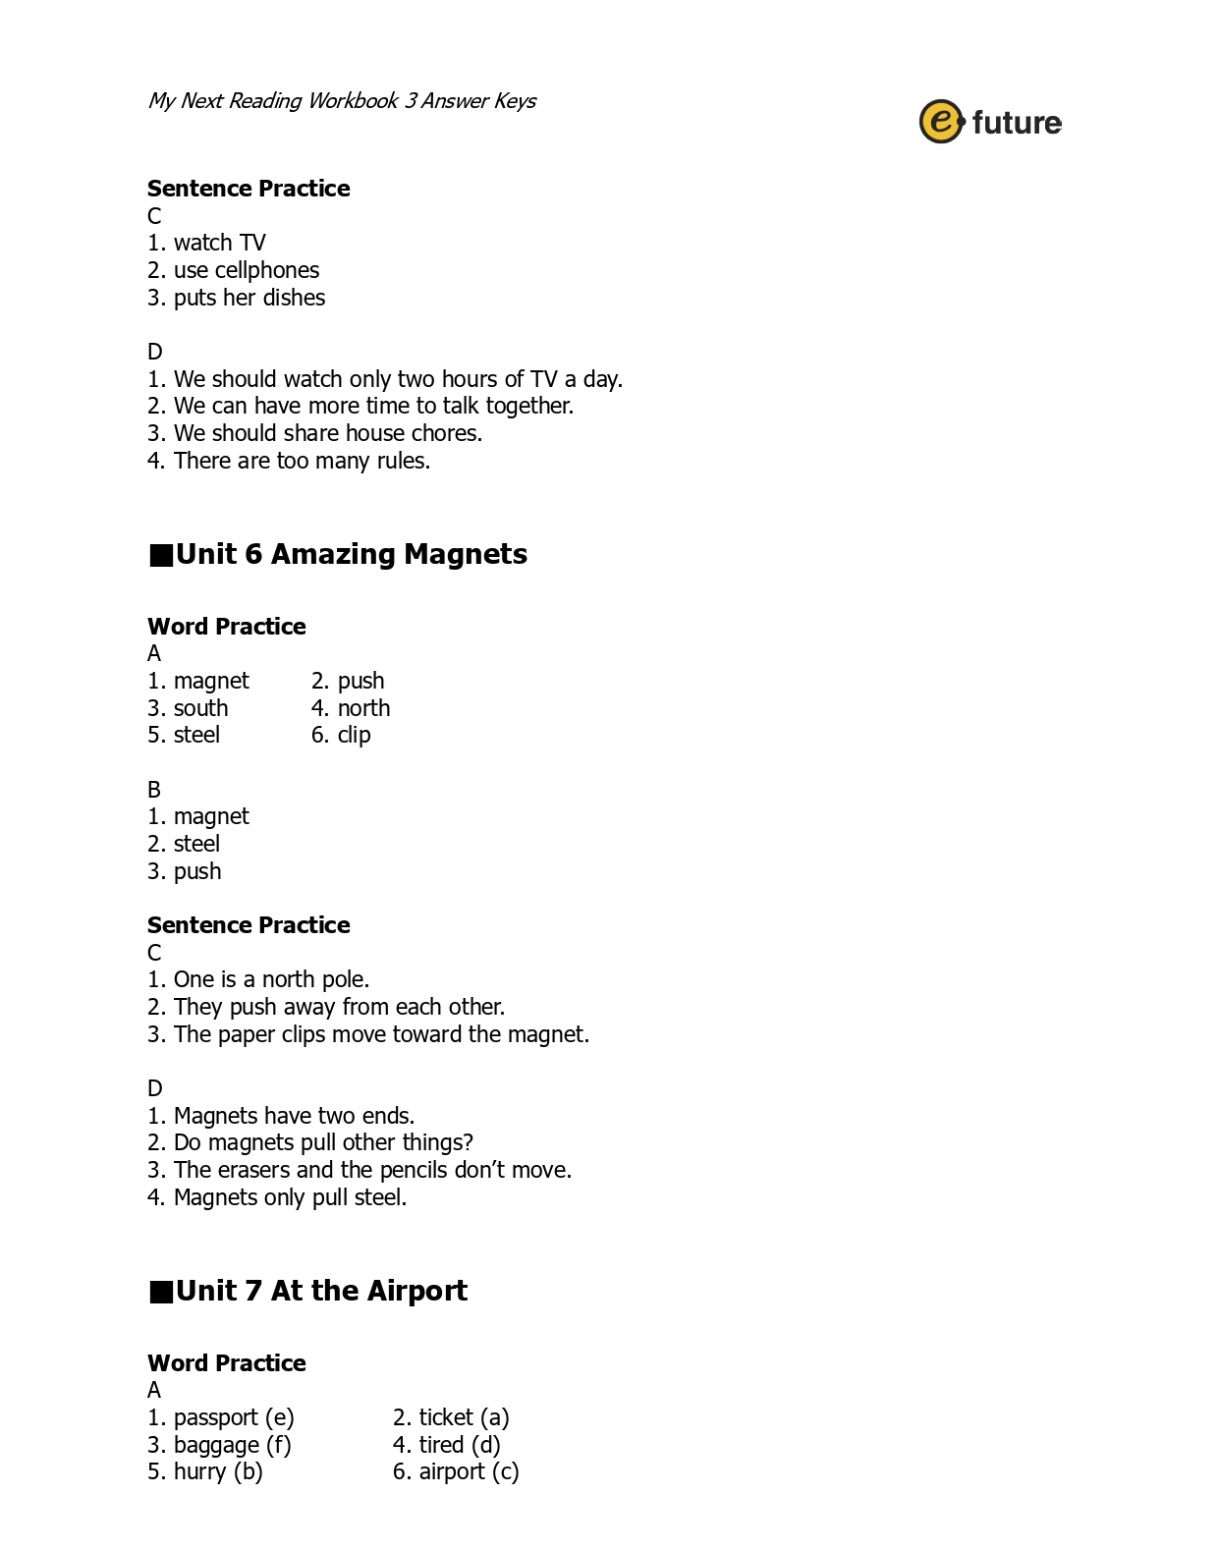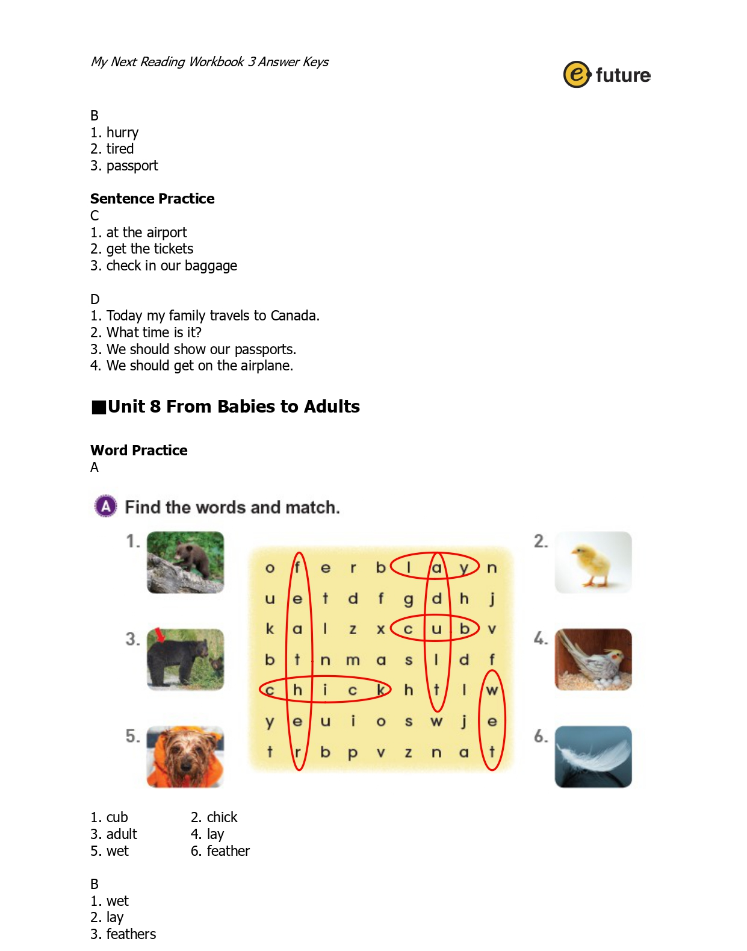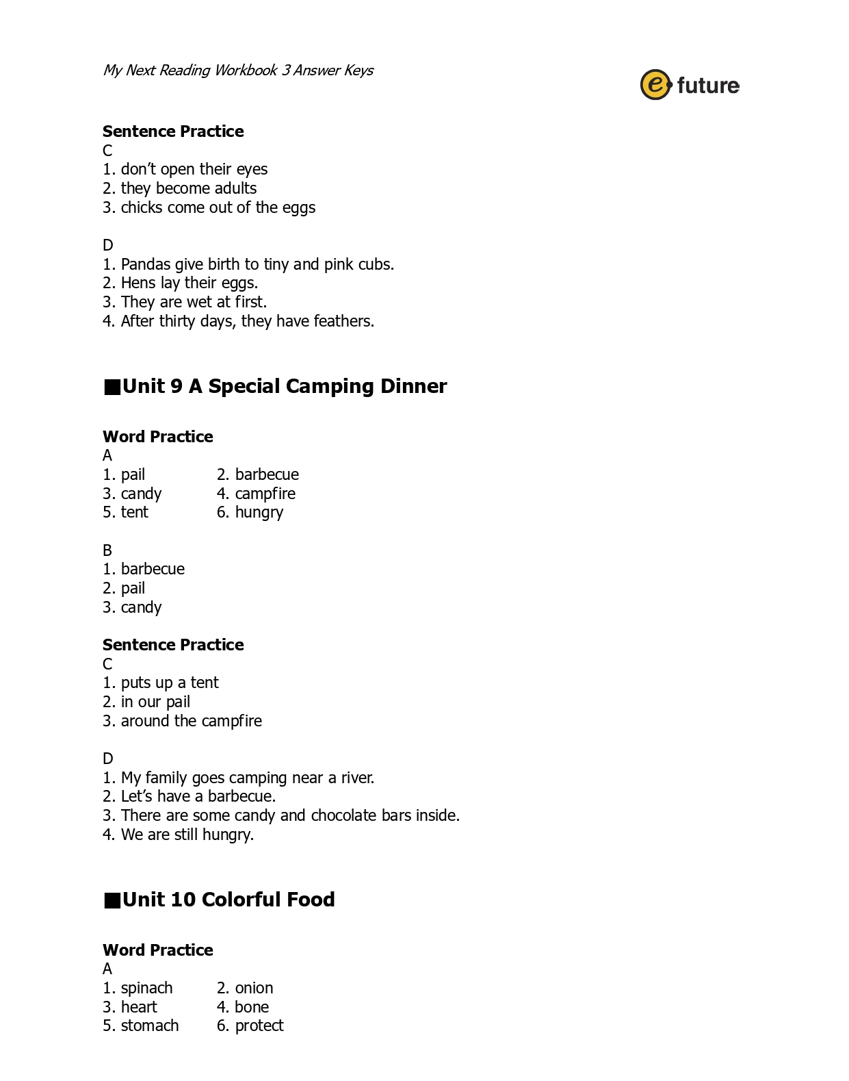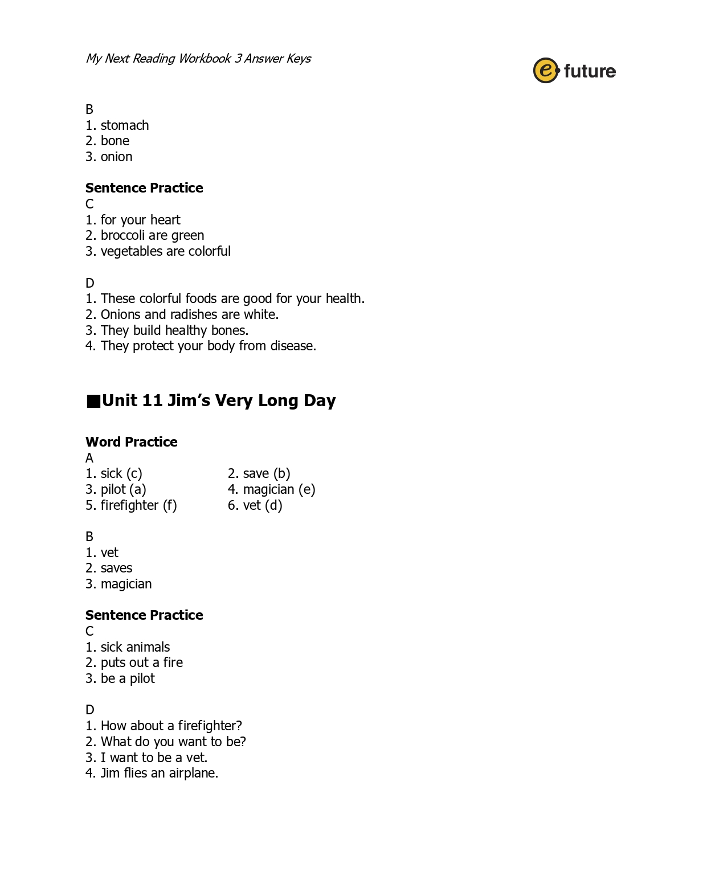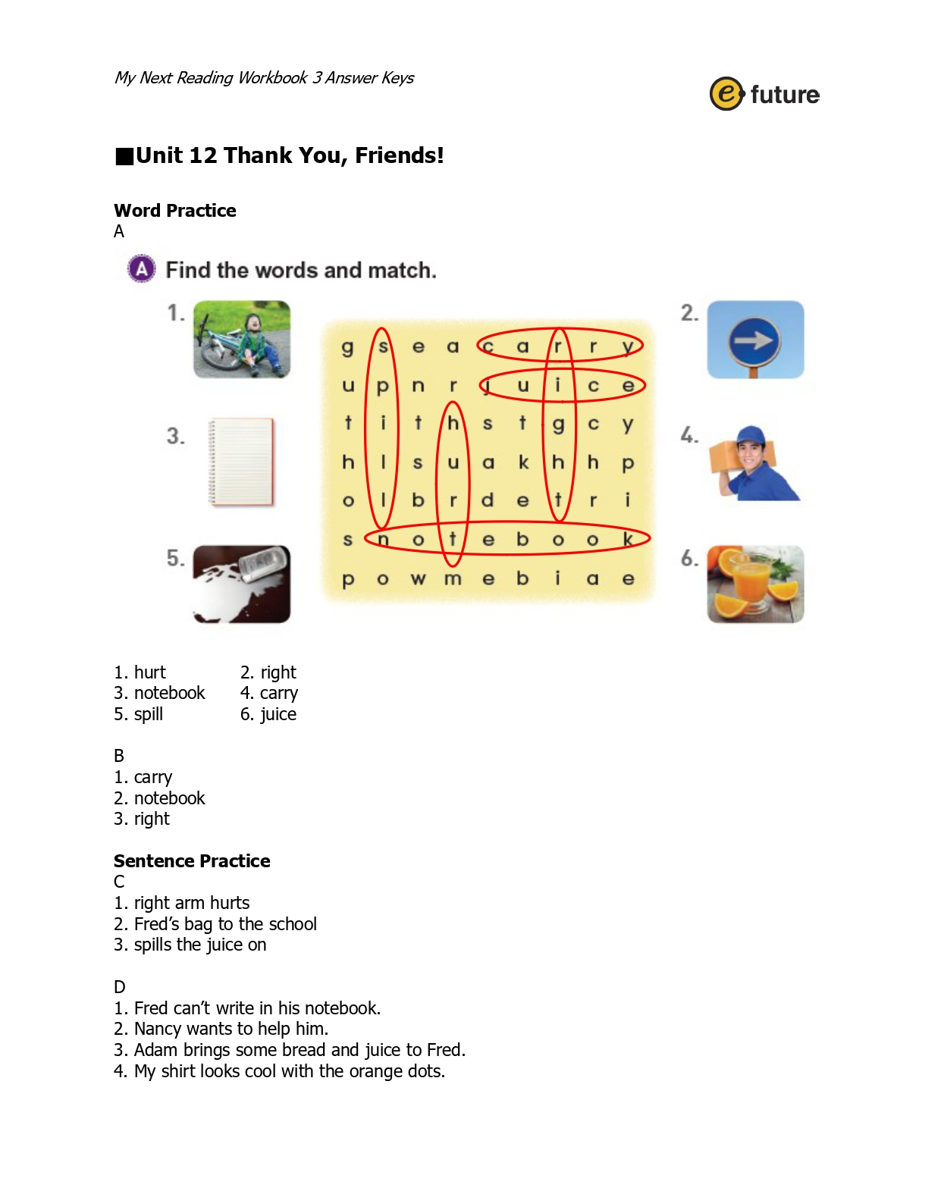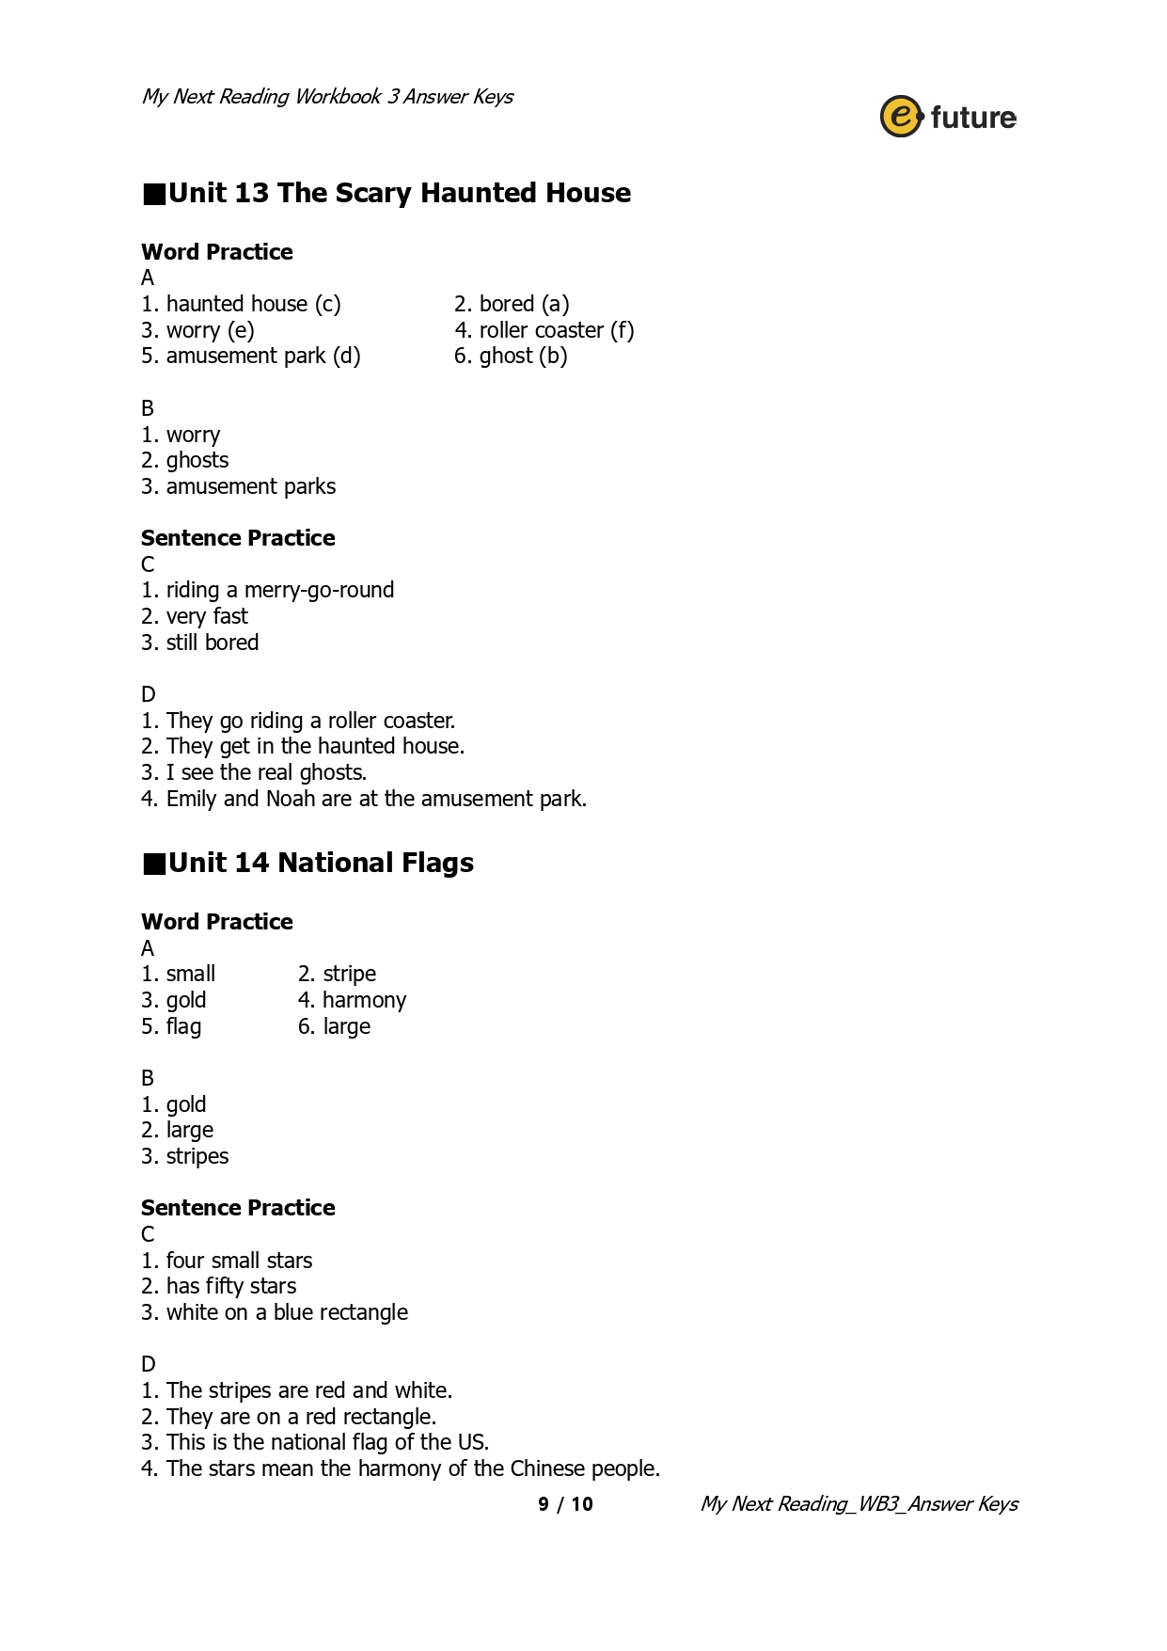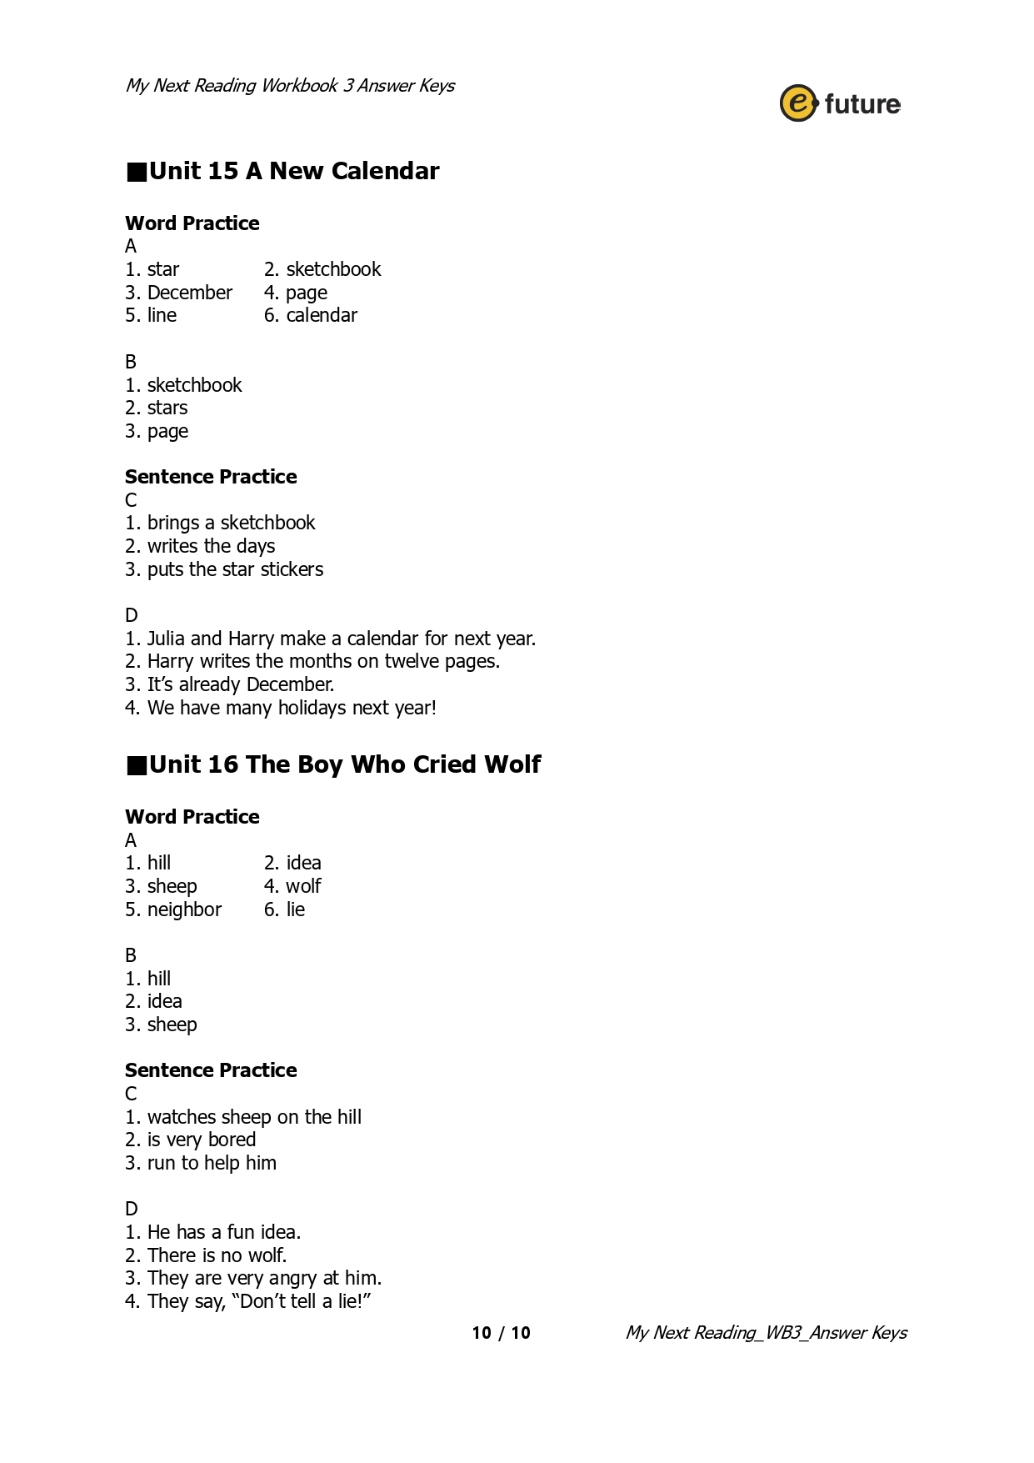
33

